UNIVERSITY INSTITUTE OF TECHNOLOGY

BARKATULLAH UNIVERSITY, BHOPAL

Department Of Computer Science & Engineering

MAJOR PROJECT

ON

SHRTS (URL SHORTENER)

(https://shrts1.herokuapp.com/ )

Submitted for the partial fulfillment of the requirement for the

Award of Degree of Bachelor of Engineering (B.E.)

Year 2020-21

By

Subhang Pati Shoaib Ahmed Aman Shrivastava

Shailesh Gotiya Ishu Kumar Verma

Under the Guidance

Of

Mrs . Kavita Chourasia Dr.Divakar Singh

Asst. Professsor Head of Department

CSE, UIT-BU CSE, UIT-BU

UNIVERSITY INSTITUTE OF TECHNOLOGY

BARKATULLAH UNIVERSITY, BHOPAL

Department Of Computer Science & Engineering

CERTIFICATE

This is to certify that Mr. Aman Shrivastava, Mr. Shoaib Ahmed, Mr. Sailesh Gotiya, Mr. Ishu Kumar Verma & Mr. Subhang Pati have successfully completed this project work titled “SHRTS(URL Shortener)” for the partial fulfillment of the award of degree of Bachelor of Engineering in Computer Science& Engineering in the year of 2020-21 from Barkatullah University Institute Of Technology, Bhopal.

We are fully responsible for the matter embodied in this project in case of any discrepancy found in the project and the project has not been submitted for the award of any other degree.

Mrs. Kavita Chourasia Dr. Divakar Singh Dr. N.K. Gaur

Project Guide Head Of Department Director

Department CSE Department UIT-BU

UIT-BU, Bhopal UIT-BU, Bhopal Bhopal

ii

DECLARATION

We hereby declare that the work which is being presented in this report entitled, "SHRTS (URL Shortener)" submitted in partial fulfillment of the requirement for the award of Degree of "Bachelor of Engineering" in Computer Science and Engineering from University of Technology, BU, Bhopal is an authentic record of our project work.

This is our original work and has not been submitted earlier for the award of any other degree, diploma or any other certificate.

Date: Mrs . Kavita Chourasia

Project Guide

iii

ACKNOWLEDGEMENT

I would like to express my special appreciation and thanks to my project guide Mrs. Kavita Chourasia . You have been a tremendous mentor for us. I would like to thank you for encouraging the project. Your advice on projects as well as on my career have been invaluable. At the onset, I would like to thank Head of Department Dr. Diwakar Singh, Department of Computer Science & Engineering, under whose guidance we are registered in the past for my Bachelors. I wish to express our sincere thanks to The Director, Dr. Neeraj Gour, UIT, BU, Bhopal, for providing me with all the necessary facilities for the project. I also place on record, my sense of gratitude to one and all, who directly or indirectly, have lent their hand in this venture.

Submitted By:-

Shoaib Ahmed(R188237200026)

Aman Shrivastava(R188237200036)

Subhang Pati(R188237200048)

Sailesh Gotiya(R188237200035)

Ishu Kumar Verma(R188237200040)

iv

ABSTRACT

This project proposes an effective method of URL Shortening Service. This proposed system is designed to create short URL and a QR Code corresponding to a long URL. URL Shortening is a technique on World Wide Web in which a Uniform Resource Locator (URL) may be made substantially shorter and still direct to the required page. This is achieved by using a redirect which links to the web page that has a long URL.

One of the most common reasons why people want a short URL is to save character space when typing messages on Twitter and other microblogging sites. These sites limit the number of characters you can use in an update and a long URL means less space for a message.

Another good reason to use a URL shortener is when you have a lengthy and unattractive URL on an ISP or free Web hosting service. In some cases you can use a shortener to have a more pleasing Web address. Short URLs are also useful when sharing an extremely long URL over instant messaging or in email where there is a chance the long link could be broken during message transmission.

v
CONTENTS

Certification |  |  | i
Declaration |  |  | ii
Acknowledgements |  |  | iii
Abstract |  |  | iv
Chapter 1 |  | Introduction
1.1 | Overview and issues involved |  | 1
1.2 | Problem Definition |  | 2
1.3 | Proposed Solution |  | 3
Chapter 2 |  | Literature Survey
2.1 | Methodology |  | 4
2.2 | Technologies and Tools |  | 5
2.3 | Existing Solutions |  | 6
Chapter 3 |  | Analysis
3.1 | Software Requirements |  | 8
3.2 | Hardware Requirements |  | 8
3.3 | Use Case Model |  | 8
3.4 | Use Case Description |  | 9
Chapter 4 |  | Design
4.1 Technology Selection |  |  | 11
4.2 Sequence Diagrams. |  |  | 12
4.3 Activity Diagram. |  |  | 15
4.4 Program
Chapter 5 Implementation and Testing |  |  | 17
Test Cases |  |  | 26
Conclusion |  |  | 30
References |  |  | 31

vi

CHAPTER 1
INTRODUCTION

1.1 Overview and issues involved :-
URL shortening is a technique on World Wide Web in which a Uniform Resource Locator (URL) may be made substantially shorter and still direct to the required page. This is achieved by using a redirect which links to the web page that has a long URL.

For example, the URL "https://example.com/assets/category_B/subcategory_C/Foo/" can be shortened to "https://example.com/Foo", and the URL, also this is just an example "https://en.wikipedia.org/wiki/URL_shortening" can be shortened to "https://w.wiki/U".

Often the redirect domain name is shorter than the original one. A friendly URL may be desired for messaging technologies that limit the number of characters in a message (for example SMS), for reducing the amount of typing required if the reader is copying a URL from a print source, for making it easier for a person to remember, or for the intention of a permalink. In November 2009, the shortened links of the URL shortening service Bit.ly were accessed 2.1 billion times.

Other uses of URL shortening are to "beautify" a link, track clicks, or disguise the underlying address. Although disguising of the underlying address may be desired for legitimate business or personal reasons, it is open to abuse. Some URL shortening service providers have found themselves on spam blacklists, because of the use of their redirect services by sites trying to bypass those very same blacklists. Some websites prevent short, redirected URLs from being posted.

There are several reasons to use URL shortening. Often regular unshorten links may be aesthetically unpleasing. Many web developers pass descriptive attributes in the URL to represent data hierarchies, command structures, transaction paths or session information. This can result in URLs that are hundreds of characters long and that contain complex character patterns. Such URLs are difficult to memorize, type out or distribute. As a result, long URLs must be copied and pasted for reliability. Thus, short URLs may be more convenient for websites or hard copy publications (e.g. a printed magazine or a book).

1
1.2 Problem definition: -

URL shortening services are popular when it comes down to shortening long URLs that have the possibility to break or are simply too long to be inserted in e-mails, posts on Social Networking websites or blogs. However, the disadvantage is that with these URL shortening services you are no longer able to see directly where your browser will be pointed.

Avoid Long URL Sharing:-

- If anyone wanted to share an URL via article, e-mail, or any other medium then it is not a good idea to put long link there because they are too messy and difficult to manage.

Example :-

What is easier to share:

This- “ http://friendfeed.com/e/b17ab777-ceb6-f7fd-841-ca3a6ca9c9d4/Flutter-Mocks-You-

Me-and-Our-Microblogging/ ”

or this – “ https://shrts.herokuapp.com/uzMIwf31i ”

  - To avoid for such problem, the generation of a short URL will be helpful as it takes less space, easy to manage and to write on search bar and attracts the reader.
- Typing URL :-

  - It will be difficult for a person to take URL input from a printed source (like magazines, newspaper, poster) even after it has been shorted.

  - If there is any kind of mistake (even of single character) while typing the URL in search bar, the this will take user to another page, may show error 404.

  - To avoid for such problem, the generation of a QR code for URL will be helpful as by scanning it, the user can be taken to the desired web page.

2
1.3 Project description : -

While Shrts is a URL shortener much like any other, its appeal is slightly unique. Shrts believes that brands, whether it's a product or a person, get value out of customizing links to content that references them from all over the web. Here free plan offers five custom domains, the most of any on our list. For example, Bob Vila could customize the link to his Wikipedia entry

from en.wikipedia.org/wiki/Bob_Vila to BobVila.Tools/wikipedia. A link to one of his books on Amazon could be BobVila.Tools/amazon-book. Vila can use these links on his own site, business cards, or in advertisements. Shrts includes tools for tracking the popularity of each link and automatic QR code generation, too. If shrts is more than you need is good works for QR generation as well.

3

CHAPTER-2
TECHNICAL DESCRIPTION

2.1 Methodology: -

First User will Enter the Long Url and Custom Alias (which is optional). Then the system will validate if the entered long url is valid or not. If the long url is not valid then it will prompt user to enter the valid URL. If the URL is valid then it will check if the entered alias is valid. If it is valid then it sends the long URL and custom alias to the server. If the alias entered by user is empty then it will generate an random unique alias. If the alias entered by user is not empty, then the server will check if the alias entered by user is already present in the database or not. If the alias is already in the present in the database then it will send an error message to user “Alias already exists”, and will ask user to enter another alias. And if the entered alias is not present in the database then the long URL and alias will be stored in the database, and it will display the shortUrl and QRCode corresponding to that long URL.

User can copy that shortUrl and paste in browser then the server will extract the alias from the URL, then it will search the database if the alias is present in the database. If the URL is not present in the database then it will show an error page to the user as “Page Not Found”. If the alias is present in the database then it will redirect user to the longUrl that is present corresponding to that shortUrl.

Our URL shortener system should meet the following requirements:

Function Requirement:

- Given a URL, our service should generate a shorter and unique alias of it.

- When users access a shorter URL, our service should redirect them to the original link

- Users should optionally be able to pick a custom alias for their URL.

- Links will expire after a specific timespan automatically, users should also be able to specify expiration time.

Non-Function Requirement:

- The system should be highly available. This is required because if our service is down, all the URL redirections will start failing.

- URL redirection should happen in real-time with minimum latency.

- Shortened links should not be guessable (not predictable).

4

2.2 Technologies and Tools

Web Application: HTML, CSS, JS

Chrome Extension: HTML, CSS, JS

Backend-server: Node.js

Database: MongoDB cloud

For Deploying Website: Heroku

Tools: VS Code, Git

npm Packages We Are Going To Use:

configuration : It lets you define a set of default parameters, and extend them for different deployment environments (development, QA, staging, production, etc.). For production, we have to define production.js similarly for development devlopment.js. By default, it will look for default.js.

This will be used to store config related to DB and others.

valid-URL: This module collects common URI validation routines to make input validation, and maintaining easier and more readable. All functions return an untainted value if the test passes, and undefined if it fails.

This will be used to validate the URL given by the user for a shortening purpose.

shortid: ShortId creates amazingly short non-sequential URL-friendly unique ids.

This will be used to generate a unique id for each shortened URL.

express: The Express philosophy is to provide small, robust tooling for HTTP servers, making it a great solution for single-page applications, web sites, hybrids, or public HTTP APIs.

This will be used to create the server and route different HTTP path.

mongoose: Mongoose is a MongoDB object modeling tool designed to work in an asynchronous environment. Mongoose supports both promises and callbacks. As they use promise we will use async and await feature of JS.This will be used for connecting with MongoDB, saving, updating and querying the DB.

5
2.3 Existing Solutions

URL shortening services have existed at least as early as 2001 , tinyURL is probably the first such, well-known, service. The rapid adoption of OSNs, and their imposed character limit for status updates, tweets and comments, has led to an increased demand for short URLs. As a consequence, dozens of such services exist today, although only a handful of them, such as bit.ly, ow.ly and tinyURL, capture the lion’s share of the market. Aside from the aforementioned services, short URLs are also useful in more traditional systems which either discourage the use of very long words, such as IMs and SMSes, or do not handle long URLs very well, such as some email clients.

Besides providing a short URL for each long one, some of these services provide statistics about the accesses of these URLs. For example, bit.ly provides information about the number of hits each short URL has received (total and daily), the referrer sites the hits came from and the visitors’ countries. For each unique long URL that it has shortened, bit.ly provides a unique global hash, along with an information page which provides the overall statistics for the URL. If a registered user creates a short URL for the same long URL, the service will create a different hash that will be given to the user so as to share it as she likes. The information page for this custom hash will contain statistics solely for the hits received by the creator’s URL. Nonetheless, overall statistics will still be kept by the global URL’s information page. Registered users can create as many custom short URLs as they like for the same long URL.

The previously discussed collection process resulted in four datasets:

• twitter : The trace contains 887,395 unique bit.ly short URLs posted on Twitter between the 22nd of April and the 3rd of May 2010. For each short URL, all the accompanied metadata are also collected.

• twitter2 : The trace contains over 7M unique bit.ly short URLs posted on Twitter between the 6th of May and the 2nd of August 2010. In this trace we limit our metadata gathering to only the total and daily accesses for each short URL.

• owly : This trace contains 674,239 ow.ly short URLs created between the 26th of April and the 3rd of May 2010. As described in the brute-force methodology, this constitutes the entire population of ow.ly short URLs created in that period.

6

- Bit.ly : Contains 171,044 unique bit.ly short URLs collected by exhaustively searching the available key space for hash sizes of 1 to 3 characters. All the accompanied metadata for each short URL are also collected.

Table 1 summarizes the data collected.

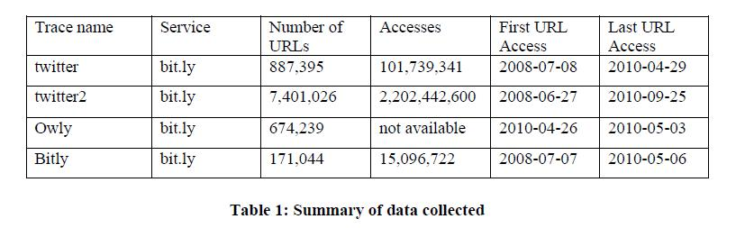

7

CHAPTER-3
ANALYSIS

3.1 Software Requirements: -

- Node.js

- MongoDB Cloud

- Heroku

- VS Code

- Postman

3.2 Hardware Requirements: -

1.Operating System: Windows 10

- RAM: 4 GB and above

- Processor- i3 (8th gen) or equivalent performance and above

3.3 Use Case Model: -
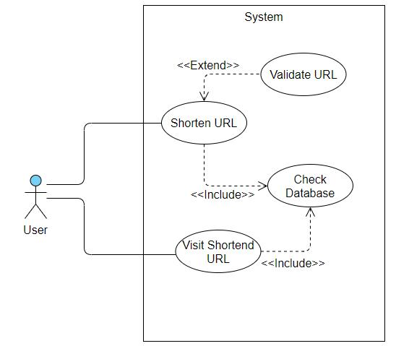

Fig 3.3.1: Use case model figure

8

3.4 Use Case Description : -

Use case 1: Shorten URL

Preconditions: System must be connected to the network.

Actors: User.

Goals: To Short the given URL.

Overview

User have to shorts a long URL, gives his long URL in the specified place and also an optional alias at the specified place. This use case will interact with user and shortens only a valid URLs and also store it into the database.

Typical course of events:

 | Actor Action |  | System Response
1. | User enters an invalid URL. | 2. | System shows error.
3. | User enters a valid URL | 4. | System shortens URL and stores into
 |  | database.

Use case 2: Visit Shortened URL

Preconditions: System must be connected to the network.

Actors: User.

Goals: To visit Shortened URL.

Overview

User have a shortened URL, and wants to visit the page with the short URL. This usecase will interact with user and finds the respective original URL of the short URL and redirect browser to the original URL.

Typical course of events:

 | Actor Action |  | System Response
1. | User enters a short URL not present in | 2. | System shows error.
database
3. | User enters a short URL which is present in | 4. | System redirect browser to the original URL.
database

9
Use case 3: Check Database

Preconditions: System must be connected to the network.

Actors: User.

Goals: To Shortened URL present in server.

Overview

User have an short URL and wants to visit the respective page or user wants to short the URL, in both the scenario, this usecase indirectly interact to user as it checks whether the short link is already available in the server or not.

Typical course of events:

Actor Action |  | System Response
1. User enters a short URL not present in | 2. | System shows error.
database
3. User enters a short URL which is present in | 4. | System redirect browser to the original URL.
database
5. User enters URL to shorten with custom key | 6. | System shows error
but the same key is already used for another
URL.
7.User enters URL to shorten with custom key | 8. | System accepts URL, shortens it and stores
and the same key isn’t used for any other URL. | it into database if not present

10

Chapter-4
Design

4.1 Technology Selection:-

Nodejs :

This technology is used as a backend server. The main idea of Node.js comes in use of non-blocking, event-driven I/O to remain lightweight and efficient in the face of data-intensive real-time applications that run across distributed devices.it works under-the-hood and is pretty interesting. Compared to traditional web-serving techniques where each connection (request) spawns a new thread, taking up system RAM and eventually maxing-out at the amount of RAM available, Node.js operates on a single-thread, using non-blocking I/O calls, allowing it to support tens of thousands of concurrent connections held in the event loop. Due to more data transfer between the load owner and load carrier node.js will help due to light weight and single thread.

MongoDB:

MongoDB is a document database, which means it stores data in JSON-like documents. We believe this is the most natural way to think about data, and is much more expressive and powerful than the traditional row/column model.

Heroku Server:

Heroku is a platform as a service based on a managed container system,

with integrated data services and a powerful ecosystem, for deploying and running modern apps. The Heroku developer experience is an app-centric approach for software delivery, integrated with today’s most popular developer tools and workflows.

11

4.2 Sequence Diagrams:-

Sequence diagram for the URL shortening process:-
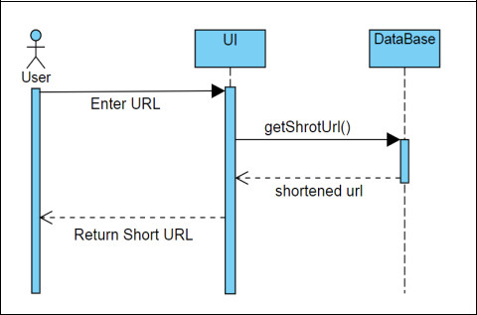

Here User interacts with UI and sends it the long URL which he wants to shorten

The UI will be active in this process until the user leaves the process. Now, after entering URL, server will check if this URL already present or not, and after that, it will return the short URL to UI and hence displayed to user.

12

Sequence Diagram for visiting shortened URL:
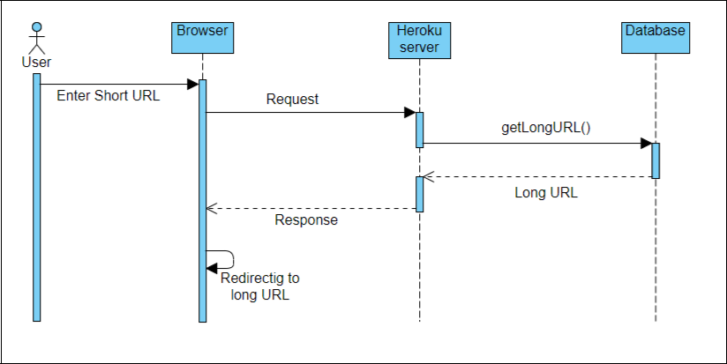

Here, the activation of the browser depends upon the user as browser is active until user closes it. User have a short URL of and wants to reach a web page with that link.

The process will be, the browser will send request to the domain “Heroku” server and the waits for the response. Heroku server will check its database and if long URL corresponding to the short URL is present, the it will send the Long URL to the browser as a response, else error 404 will be displayed.

The browser will then redirect the search to long URL and opens the desired web page.

13
4.3 Activity Diagram:-

Activity diagram for URL shortening process :
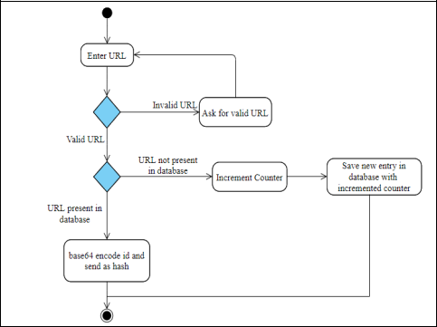

Here, after start, user enters the URL and condition is checked “Whether the input URL is valid or not?” If URL is not valid, then system will ask for valid URL, else process will continue further. Now, another decision making stage is appeared and decision is made on “Whether the URL is already present in system or not?” If URL is not present, the counter value is increased and the new URL is stored in database along with counter, else the stored one will be encoded and send to user. After sending response, the system terminates.

14

Activity Diagram for visiting shortened URL:
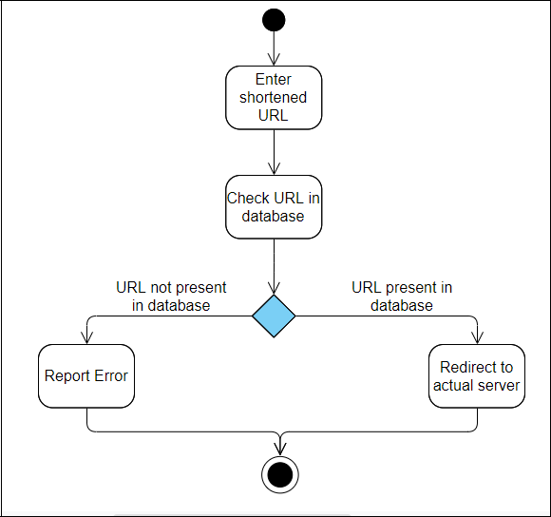

Here, short URL is entered in browser and it is then checked whether it is present in the database or not. There will be an encounter with decision making stage which is decided by “Whether the entered URL present in the database or not?”

If URL is present in database, then it will redirect browser to the actual server where the user wants to go, else there will be an error of page not found (error 404). After all this, the end stage occurred and process terminates.

15
4.4 Flow Diagram :-

Flow diagram for URL shortening process:
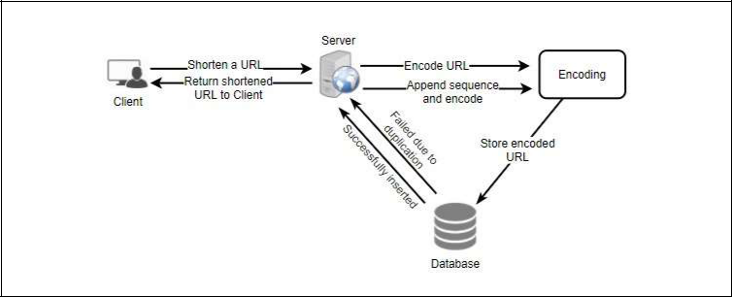

Flow diagram for visiting shortened URL:
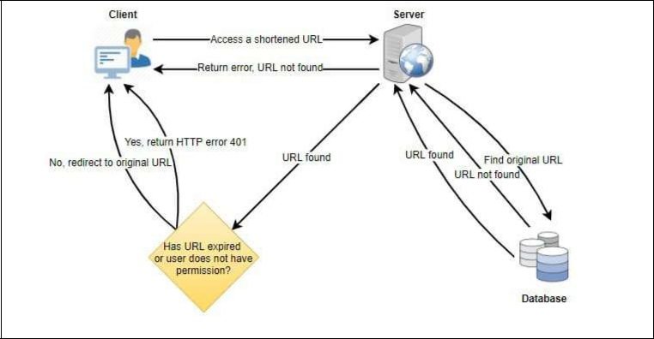

16

PROGRAM

bin/env node

var app = require('../app');

var debug = require('debug')('server:server');

var http = require('http');

/**

* Get port from environment and store in Express.

*/

var port = normalizePort(process.env.PORT || '3000');

app.set('port', port);

/**

* Create HTTP server.

*/

var server = http.createServer(app);

/**

* Listen on provided port, on all network interfaces.

*/

server.listen(port);

server.on('error', onError);

server.on('listening', onListening);

/**

* Normalize a port into a number, string, or false.

*/

function normalizePort(val) {

var port = parseInt(val, 10);

if (isNaN(port)) {

// named pipe

return val;

}

17

if (port >= 0) {

return port;

}

return false;

}

/**

* Event listener for HTTP server "error" event.

*/

function onError(error) {

if (error.syscall !== 'listen') {

throw error;

}

var bind = typeof port === 'string'

? 'Pipe ' + port

: 'Port ' + port;

// handle specific listen errors with friendly messages

switch (error.code) {

case 'EACCES':

console.error(bind + ' requires elevated privileges');

process.exit(1);

break;

case 'EADDRINUSE':

console.error(bind + ' is already in use');

process.exit(1);

break;

default:

throw error;

}

}

/**

* Event listener for HTTP server "listening" event. */

18

function onListening() {

var addr = server.address();

var bind = typeof addr === 'string'

? 'pipe ' + addr

: 'port ' + addr.port;

debug('Listening on ' + bind);
}

MODEL :

var mongoose = require('mongoose');

var Schema = mongoose.Schema;

const urlSchema = new Schema({

shortCode: {

type: String,

required: true,

unique: true

},

longUrl: {

type: String,

required: true

},

lastAccessed: { type: Date, expires: 3600*24*30*6, default: Date.now },

},{

timestamps: true

});

module.exports = mongoose.model('Url', urlSchema);

19
Home.js

$(document).ready(function(){

$("#longUrl")

.on('keypress',function(e) {

if(e.keyCode == 13) {

e.preventDefault();

$("#alias").focus();

}

});

$("#alias")

.on('keypress',function(e) {

if(e.keyCode == 13) {

e.preventDefault();

$("#shortenBtn").click();

}

});

$("#copy-btn")

.on("click", function(){

copyToClipboard();

$('#copy-btn')

.removeClass('btn-secondary')

.addClass('btn-success')

.html("Copied");

setTimeout(function(){

$('#copy-btn')

.removeClass('btn-success')

.addClass('btn-secondary')

.html("Copy");

}, 2000);

});

$('#goToUrlBtn')

.on('click', function(){

20

var url = $("#shortUrl").val();

window.open(url, '_blank');

});

$('#shortenBtn')

.on('click', function(){

$('#shortUrlContainer, #status, #qrImage').addClass('hide');

$("#qrImage").attr("src", '');

var longUrl = $('#longUrl').val();

var alias = $('#alias').val()

if(!checkForValidUrl(longUrl)) {

$('#status').html("Long Url Not Valid").removeClass('hide');

return 0;

}

if(isUrlShortened(longUrl)) {

$('#status').html("shrts1.herokuapp.com/ URL can't be Shortened").removeClass('hide');

return 0;

}

if(checkForValidAlias(alias)) {

$('#status').html("Alias May Contain Only (A-Z),(a-z),(1-9),(-),(_)").removeClass('hide');

return 0;

}

if(!checkForValidLengthOfAlias(alias)) {

$('#status').html("Alias must be atleast 4 characters long").removeClass('hide');

return 0;

}

loading();

urlShorten(longUrl, alias);

});

});

function copyToClipboard() {

var copyText = document.getElementById("shortUrl");

copyText.select();

copyText.setSelectionRange(0, 99999);

document.execCommand("copy");

21

function checkForValidUrl(url) {

var regexp = /(http|https):\/\/(\w+:{0,1}\w*@)?(\S+)(:[0-9]+)?(\/|\/([\w#!:.?+=&%@!\-\/]))?/;

return regexp.test(url);

}

function isUrlShortened(url) {

if (url.indexOf("https://shrts1.herokuapp.com") !== -1 || url.indexOf("http://shrts1.herokuapp.com") !== -1 || url.indexOf("shrts1.herokuapp.com") !== -1) {

return true;

}

return false;

}

function checkForValidAlias(alias) {

var regexp = /[^A-Za-z0-9_-]+/;

return regexp.test(alias);

}

function checkForValidLengthOfAlias(alias){

if(alias.length < 4 && alias.length > 0) return false;

return true;

}

function urlShorten(longUrl, alias) {

var t;

var data = {

'longUrl': longUrl

};

if(alias.length){

data.shortCode = alias;

}

var xhr = $.ajax({

type: 'POST',

url: 'https://shrts1.herokuapp.com/api/url/',

data: data,

error: function (err) {

22

clearTimeout(t);

removeLoader();

$('#status').html('Server Not Responding, Try again later.').removeClass('hide');

return 0;

},

success: function (response) {

clearTimeout(t);

try {

handleActions(response);

} catch (e) {

removeLoader();

$('#status').html(e.message).removeClass('hide');

return 0;

}

}

});

t = setTimeout(function(){

xhr.abort();

removeLoader();

$('#status').html('Server Not Responding, Try again later.').removeClass('hide');

return 0;

},8000)

}

function handleActions(response) {

if(!response.success) {

removeLoader();

$('#status').html(response.message).removeClass('hide');

return 0;

}

$("#longUrl").val('');

$("#alias").val('');

$("#shortUrl").val(response.shortUrl);

removeLoader();

generateQRCode(response.shortUrl);
23

$('#shortUrlContainer').removeClass('hide');

}

function loading(){

$('#shortenBtn').html('Loading...');

}

function removeLoader(){

$('#shortenBtn').html('Shorten');

}

function generateQRCode(shortUrl) {

$("#qrImage")

.attr("src", 'http://chart.apis.google.com/chart?cht=qr&chs=180x180&choe=UTF-8&chld=H|0&chl=' + shortUrl );

$('#qrImage')

.removeClass('hide');
}

Index.js

var express = require('express');

var router = express.Router();

var app = express();

const Url = require('../models/url');

/* GET home page. */

router.get('/', function(req, res, next) {

res.render('pages/home',{title: 'Shrts'});

});

router.get('/:shortCode', async (req, res, next) => {

var shortCode = req.params.shortCode;

await Url.findOneAndUpdate({"shortCode": shortCode},{

$set: {

"lastAccessed": new Date()

}

},{
24

new: true

})

.then((url) => {

if(url)

res.redirect(url.longUrl);

else {

res.render('pages/error',{title: 'Shrts | Page Not Found'});

}

},(err) => next(err))

.catch((err) => next(err));

});

module.exports = router;

app.js

var createError = require('http-errors');

var express = require('express');

var path = require('path');

var cookieParser = require('cookie-parser');

var logger = require('morgan');

var config = require('./config');

var indexRouter = require('./routes/index');

var urlRouter = require('./routes/urlRouter');

var cors = require('cors');

const mongoose = require('mongoose');

const mongoUrl = config.mongoUrl;

const connect = async() => await mongoose.connect(mongoUrl, { useNewUrlParser: true, useUnifiedTopology: true });

connect().then((db) => {

console.log('Connected Correctly to server.')

}, (err) => {

console.log(err);

});

26

var app = express();

app.use(cors());

// view engine setup

app.set('views', path.join(__dirname, 'views'));

app.set('view engine', 'ejs');

app.use(logger('dev'));

app.use(express.json());

app.use(express.urlencoded({ extended: false }));

app.use(cookieParser());

app.use(express.static(path.join(__dirname, 'public')));

app.use('/', indexRouter);

app.use('/api/url', urlRouter);

// catch 404 and forward to error handler

app.use(function(req, res, next) {

res.redirect('/');

});

// error handler

app.use(function(err, req, res, next) {

// set locals, only providing error in development

res.locals.message = err.message;

res.locals.error = req.app.get('env') === 'development' ? err : {};

// render the error page

res.status(err.status || 500);

res.render('error');

});

module.exports = app;

25

Chapter – 5
Implementation and Testing

5.3 Test Cases

Test 01 : Test case for success
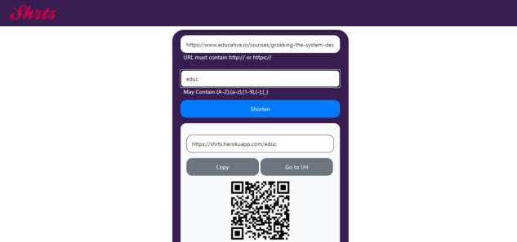

Here URL is valid and also key is unique for the in the system for this URL, so URL is successfully shortened
Test 02 : Test case for error (duplicate Key)

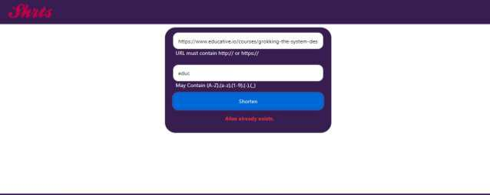

Here, URL is valid, but the key was already taken by another URL. So error is occurred.

26
Test 03 : Test case for error (Invalid URL)

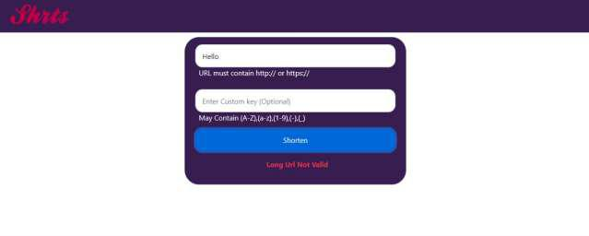

Here, the intered URL is not valid, so error is occurred.

Test 04 : Test case for error (Invalid Key)

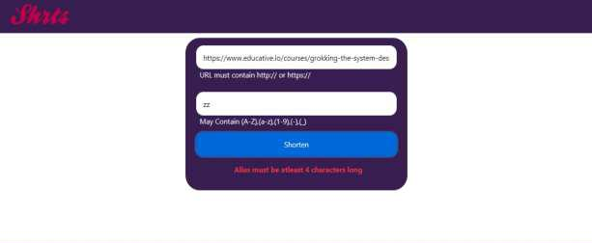

Here, the key length is small than 4 which is not valid. So error is occurred.

27
Test 05 : Test case for error (Invalid Key)

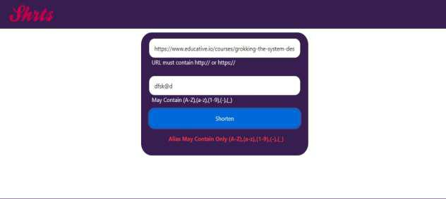

Here, key have a special character which is invalid according to implementation. So error occurred.

Test 06 : Test case for error (Shorting Shortened URL)

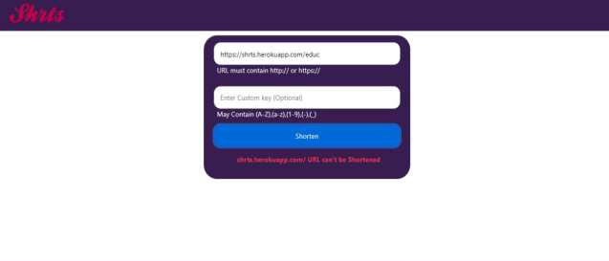

Here, the URL entered in entry field is already shortened, further shortening is not possible.

Hence URL is invalid and so error occurred.

28
Here, chrome extension is extended to the chrome and a random website is visited. After clicking on the shrts extension, a respective short URL of that web page is created and QR code is generated too.
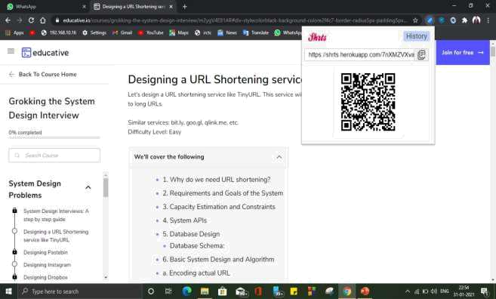
Test 07: Test case for extension and QR code

29

Conclusion

User can able to enter long URL, and custom alias (which is optional). First it will check if the Long URL is valid or not.It will check if the custom alias exist already or not. If Yes, then it will show error. If No, then it will store the long url, and short Code into database, and send short URL to user as a result.If user doesn’t enter custom alias then it will generate a unique shortId, and then create the short URL.It will also generate the QR corresponding to URL. URoriginal User can copy the short Url with the help of copy button. User can scan QR Code in their phone to go to long Url.The Generated short URL will automatically deleted from database after 6 months of last access. User will enter short Url into Browser. If that short Url is not present in the database then it will show “Page Not Found”error.If short Url is present in the database then it will retrieve the long Url from the database corresponding to that long Url, and redirects User to that long Url.

30

References :-

- https://en.wikipedia.org/wiki/URL_shortening, URL Shortening

- https://medium.com/javascript-in-plain-english/creating-a-url-shortener-with-node-js-and-mongodb-db4bc6488445, Creating a URL shortener with Node.js and MongoDB

- TinyURL.com. http://tinyurl.com/.

- Bitly https://bit.ly/.

31

